Waste Anesthetic Gases, Nothing to Just WAG a Tail At
By: Michelle McConnell, LVT, VTS (A&A)

The total effects of waste anesthetic gases (WAG) are mostly unknown but could be harmful in even trace amounts. Early in veterinary medicine WAG scavenging was not even utilized. Some early anesthesia machines still in use today vent WAG from the pop-off valve directly into the room.
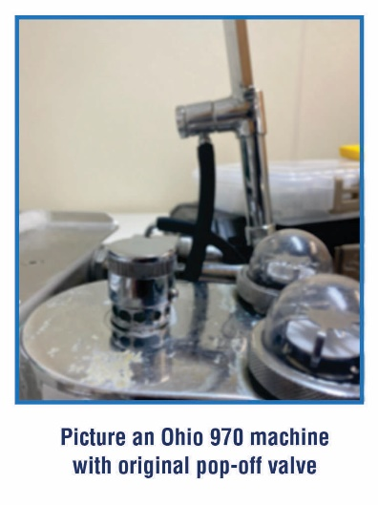
Every attempt should be made to limit WAG exposure to veterinary personnel. Every anesthesia machine should incorporate a WAG scavenging system to decrease the amount of harmful exposure. Your anesthesia machine service company should always test this system to ensure there are no leaks. WAG scavenging is the process of collecting overflow of excess gases in a collection system. In this article, we will concentrate on two different types of WAG scavenging: passive and active.

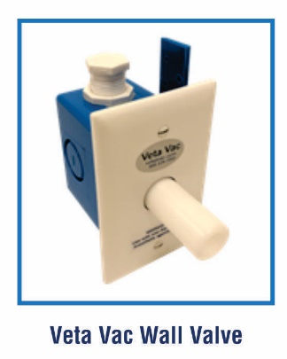
In a passive scavenging system, WAG is passively removed by the patient and oxygen flow. In most passive systems an activated charcoal canister is utilized with corrugated tubing connected to the pop-off valve. It is recommended to weigh the canister after every surgery to ensure the amount of weight gain is still within limits. Check with the manufacturer of the activated charcoal canisters on recommended weights. Most often the canister should be replaced when it has absorbed 50 grams of weight but there are some in the veterinary market that can absorb up to 200 grams.

Some passive systems are a corrugated tube connected to the pop-off valve that extends through the exterior wall of the building. Vetamac does not recommend these types of passive systems. Back flow, the path of least resistance and outside occlusions are all a concern with these systems.

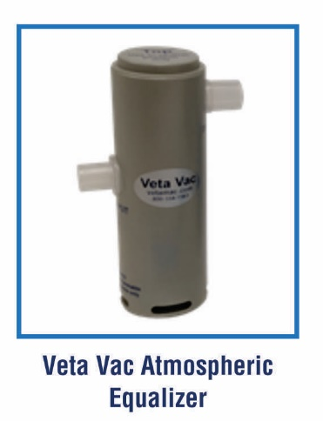
In an active system, WAG is removed at the pop-off valve by the use of a vacuum fan power unit. The power unit is mounted on an exterior wall allowing waste gases to be safely vented outside. This is the preferred method of WAG scavenging. An active system requires PVC pipe plumbed from the power unit to each scavenging station. Each station requires a ceiling or wall mounted balancing valve and each anesthetic machine requires an atmospheric equalizer. Active scavenging is more costly up front but usually pays for itself in a few years by eliminating the cost of activated charcoal canisters.

In conclusion, every attempt should be made to decrease harmful WAG exposure to personnel ensuring a safe work environment. Whether you have a passive or active scavenging system, the system should be tested at least annually for leaks and to ensure all components are functioning correctly.

Works Cited: Dorsch and Dorsch Fifth Edition

