Pet Loss and Suicide Prevention for Veterinary Professionals

Dedicated to Mango McConnell 4/12/2009-5/1/2021
By Michelle McConnell, LVT, VTS (A&A)

I wanted to get a little personal in this article of Vapors. I lost my Golden Retriever Mango, and I was not prepared for the loss and grief that hit me like a hurricane. I have been in this profession for over 20 years and thought I would be able to cope and heal. I was not and had a very difficult time. This is what I learned. It is ok to reach out for help. It is ok and normal to take time to grieve and heal. So often as veterinary professionals, we do not take the proper time to grieve and recover from pet loss whether it is a beloved pet of our own or a client's beloved pet. Coping with the guilt is a very real thing. You should never feel guilty when grieving for your pet or a client's pet.
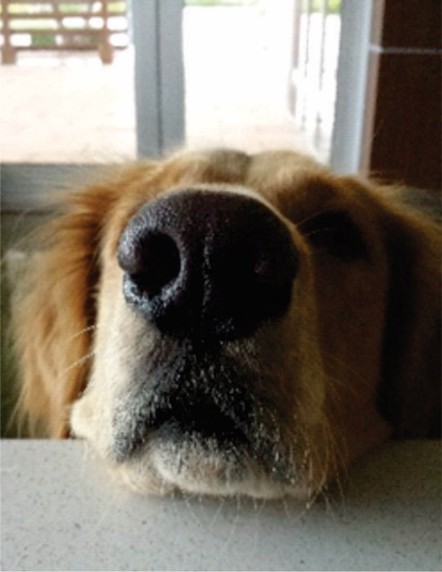
This is a normal and real feeling. Remember to make time for self-care during the grieving process and take care of yourself.

Compassion fatigue is a very real thing in the veterinary profession and sadly it is leading to veterinary professionals committing suicide. Veterinary professionals deal with death and illness daily and it can quickly lead to personal trauma. Veterinary professionals deliver unpleasant news to clients and have clients that are unable to financially afford the care that is needed for their pet which is traumatic as well.

Compassion fatigue can be mental, physical or both. Again, self-care is so important. If you are experiencing, or think you may be experiencing compassion fatigue, go to avma.org and complete the “Professional Quality of Life Assessment” then build a self-care plan. Take time for yourself and if you are in crisis, please reach out for help. It is ok to not be ok so please reach out for help. Always remember you, your thoughts, and feelings matter.

Often when a veterinary professional suffers the loss of an animal, society does not deem this as a profound loss, when in fact the death of a beloved pet can be devastating to a person.

Pet Loss and Suicide Hotlines:

ASPCA (877) GRIEF-10

C.A.R.E. Pet Loss Helpline,
University of Illinois (877) 394-2273

National Suicide Prevention Hotline (800) 273-8255

University of Tennessee Veterinary Social

Work Program (865) 755-8839

Not One More Vet
www.nomv.org

