We all Pressure Test our Circle System,
but What about our Non-Rebreathing System?
By Michelle McConnell, LVT, VTS (A&A)

First, let's review pressure testing your circle system and anesthesia machine. It is important for patient and staff safety to perform a pressure test before every procedure and after every carbon dioxide absorbent change. This will ensure the machine does not have any leaks of hazardous waste anesthetic gas (WAG). Hazardous WAG leaks put staff in danger of potential exposure to anesthetic gas. Also, if the machine is leaking this could endanger the patient during the anesthetic episode.

Below are the step-by-step instructions for pressure testing your anesthesia machine with a circle circuit and bag:
• Occlude the inspiratory & expiratory ports using a circle circuit and your thumb.
• Place bag on re-breathing bag port.
• Close the pop-off valve.
• Since the bag is compliant, use the flush valve until the manometer reads 20 cmH2O.
• Use flowmeter to bring pressure up to 30 cmH2O.
• Set the oxygen flow at 300cc/minute. Observe the manometer.
• The pressure on the manometer should remain constant or rise.
If the pressure begins to drop, there is a leak in the system that needs to be isolated.
• Release pressure by opening pop-off valve before removing your thumb from breathing circuit.

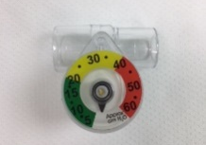
Next, lets cover pressure testing a non-rebreathing system. This circuit is often overlooked, not pressure tested, and may have hazardous leaks. To correctly pressure test a non-rebreathing system we need to utilize a non-rebreathing manometer. These non-rebreathing manometers connect where the bag attaches to the circuit. Vetamac recommends using the non-rebreathing manometer to ensure patient safety while manually ventilating the patient. This eliminates the risk of barotrauma while ventilating the patient.

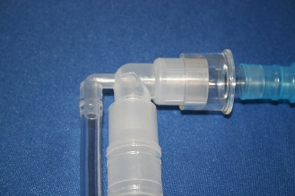
Below are the step-by-step instructions for pressure testing a non-rebreathing system utilizing a non-rebreathing manometer.
• Attach the bag with manometer.
• Connect the fresh gas tubing to a fresh gas source on the anesthesia machine.
• Occlude the patient connection and the blue waste gas hose (an adapter included
with the circuit can be used for this).
• Using the flowmeter, inflate the bag until it reaches 20 cmH20 on the manometer.
• Set the oxygen flow at 300cc/minute. Observe the manometer.
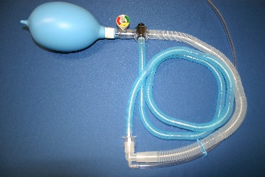
• The pressure on the manometer should remain constant or rise.
If the pressure begins to drop, the circuit has a leak and should be discarded.

If you find a leak in the circle circuit, bag, or non-rebreathing circuit, the defective component should be discarded and replaced with new. Vetamac recommends having extra circuits and bags for this reason.
If you find the anesthesia machine is leaking it should be removed from use until the leak is isolated and corrected. If the leak cannot be detected call your certified Vetamac service technician to repair the machine.

Reference:
Cooley, Kristen G and Johnson, Rebecca A. Veterinary Anesthetic and Monitoring Equipment, First Edition, 2018, Wiley Blackwell

